CSA 283: Exam Two

Name: ______________________________________ Section: _____ _____

Please write legibly. Ask questions if something is unclear. Write down any assumptions you make.

EXAM IS PRINTED ON BOTH SIDES OF THE PAGE.

- Give definitions for the following terms using one or two sentences. If the term is includes an acronym, also state what the letters in the acronym stand for. (15 points)

a. Tunneling:

b. Gateway router

c. Intra-AS Routing Protocol:

d. Estimated RTT

e. MTU

- Suppose the following two segments where transmitted at the same time:

Segment One Characteristics:
  - Source address: IP1
  - Destination address: IP3
  - Source port 100
  - Destination port 400.
- Segment Two Characteristics:
  - Source address: IP2
  - Destination address: IP3
  - Source port 100
  - Destination port 400.

    - Would it be possible for these two segments to have been transmitted using TCP? Why or why not? If it is possible, could the two segments be received by the same socket? (4 points)

    - Assuming that both packets reach their final destination and are transmitted using UDP, will the two UDP packets be received by the same socket? Why or why not? (4 points)

- Host A has calculated the congestion window to be 7,000 bytes. The receive window for Host B to which the host A is sending data is 8,000 bytes. Host A has transmitted 6,000 bytes of data. 3,000 of these bytes have been acknowledged. What is the maximum number of bytes Host A can transmit to Host B at this time? Explain/show your reasoning. (4 points)

- How is the receive window calculated? Why is it important? Be concise.
(4 points)

- A block of data for transmission using the TCP protocol has been broken up for transmission into four separate segments.
- The sequence number of the first segment is 1200.
- The first segment contains 300 bytes.
- The second segment contains 100 bytes.
- The third segment contains 400 bytes
- The fourth segment contains 200 bytes

- Complete the following table by writing the correct sequence number for each segment and the sequence number that would be used by the receiver to indicate in order receipt of each segment (Nothing is lost. All arrive in order.) (8 points)

 | Segment Sequence Number | Acknowledgement Number
First Segment
Second Segment
Third Segment
Fourth Segment

Recall that TCP uses cumulative acks. Suppose that segments actually arrive at the receiving end in the following order.

Third segment, Fourth Segment, First segment, Second Segment

- Give the TCP acknowledgement that will be sent for each segment if the receiver is using a Go-Back-N protocol. (4 points)

_______ ACK when Third segment arrives

_______ ACK when Fourth segment arrives

_______ ACK when First Segment arrives

_______ ACK when Second Segment arrives

- Give the TCP acknowledgement that will be sent for each segment if the receiver is using a Selective-Repeat protocol. (4 points)

_______ ACK when Third segment arrives

_______ ACK when Fourth segment arrives

_______ ACK when First Segment arrives

_______ ACK when Second Segment arrives
- Figure 1 is a simple network diagram. The network includes three hosts (A, B, and C) and one router. The router is performing Network Address Translation (NAT) using the NAT table below the figure. An application on host B (port 3200) sends a datagram containing an HTTP request to an application running on a host, Z, in the Internet with an IP address of 134.75.29.5 and a port number of 80.
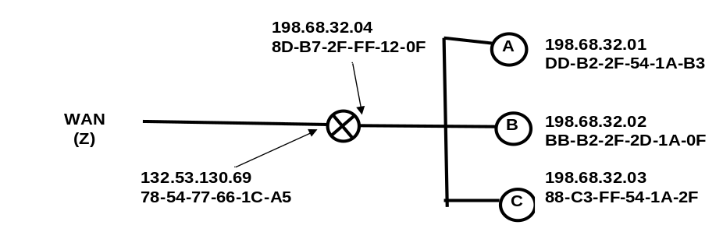
Figure 1: Simple Network with a Router Using the NAT Protocol
NAT Translation Table
WAN side address | LAN side address
132.53.130.69, 4500 | 198.68.32.01, 3200
132.53.130.69, 3250 | 198.68.32.02, 3200
132.53.130.69, 2200 | 198.68.32.02, 4500
132.53.130.69, 2100 | 198.68.32.03, 3200
… | …
Fill in the source and destination IP addresses and port numbers that will be carried in datagrams at the following four points in the network.
(8 points)

 | Outgoing |  |  | Incoming
 | From B to router | From router to Z | From Z to router |  | From router to B
Source IP
Source Port
Dest. IP
Dest. Port

- How many bytes are in an IPv6 IP address? ________________ (3 points)

- Describe the primary reason for switching from IPv4 to IPv6. (no more than two sentences) (4 points)
- TCP congestion control uses the number of duplicate acks and timeouts to determine the transmission rate. Assume the following events:

- Transmission of data begins at time 0 (RTT 0) with a congestion window size equal to 1 MSS (Maximum Segment Size).
- Three duplicates acks are received between RTT 2 and RTT 3.
- A timeout event occurs between RTT 8 and RTT 9.
- Positive acks received during all other RTT intervals

Write the size of the congestion window and the threshold for each RTT period in terms of MSS. The CongWin should be adjusted at the end of each RTT interval based on what happens in the interval. (12 points)

Time | Size of congestion Window (CongWin) in Maximum Segment Sizes (MSS) | Threshold in MSS
0 RTT | 1 | ∞
1 RTT
2 RTT
3 RTT
4 RTT
5 RTT
6 RTT
7 RTT
8 RTT
9 RTT
10 RTT
11 RTT
12 RTT
- Below is a portion of a routing table.

Prefix | Link Interface
11001111 00010011 1001 | 0
11001111 00010011 10011001 | 1
11001011 00010111 00011 | 2
Otherwise | 3

- Give the Classless InterDomain Routing (CIDR) notation for the subnets identified by the first two rows of the table (for example 200.23.16.0/23). Indicate approximately how many hosts each sub-net could contain. (8 points)

CIDR notation Approx. Number of Hosts

________________________ __________

________________________ __________

- Using the destination IP addresses, determine which link interface each of the following packets should be sent to. (6 points)

Destination IP Address | Link Interface
11001111 00010011 10011001 11011101
11001111 00010011 10010011 00011000
11001011 00010101 00011000 10101101

- Fast retransmit occurs after a timeout in order to avoid an extended delay before resending a lost packet. (2 points)

TRUE FALSE

- TCP uses network assistance for congestion control. (2 points)

TRUE FALSE

- The TCP protocol uses a three way handshake to establish a connection.
(2 points)

TRUE FALSE

- IP addresses are used by the transport layer for multiplexing and demultiplexing. (2 points)

TRUE FALSE
- Using node A in Figure 2 as the source, show the step by step results of link state (LV) algorithm to find the shortest path to all other nodes. Show the members of N, the predecessor of each destination, and the shortest known distance to each destination after the initialization phase of the algorithm and after each iteration of the main loop.
(14 points)
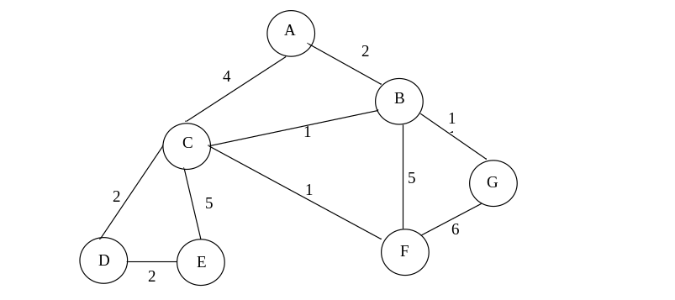
Figure 2: Network Graph

- Write down the shortest path to all destinations in Figure 1 using the predecessor data in the table you created in the previous question. In other words drawn the minimum spanning tree (MST). (7 points)

- Assume MTU = 500 bytes, break the following datagram (containing 1920 bytes of data) into as many fragments as necessary. For each fragment, give the length, fragmentation flag value, and the offset (both, length and offset should be in bytes). Assume all IP headers are 20 bytes long. (8 points)

Original Datagram:

 | Length = 1940 | ID = 22 | Fragflag = 0 | Offset = 0

Fragments (Create as many as necessary):

 | Length | ID | Fragflag | Offset
 | Length | ID | Fragflag | Offset
 | Length | ID | Fragflag | Offset
 | Length | ID | Fragflag | Offset
 | Length | ID | Fragflag | Offset

- Consider the following transport and network layer protocols. Place Xs in the following table to indicate what mechanism each protocol uses to deal with various types of transmission errors. If a mechanism is not applicable to the protocol or is not applicable to the problem leave the cell blank. Assume numerous pipelined segments.(12 points)

 |  | Problem
Protocol | Mechanism | Lost Packets | Duplicate  Packets | Corrupt Packets | Out of Order Packets
UDP | Sequence Numbers
UDP | Timers
UDP | Checksums
TCP | Sequence Numbers
TCP | Timers
TCP | Checksums
IP (v4) | Sequence Numbers
IP (v4) | Timers
IP (v4) | Checksums

